Lenten Anointing

How delightful is the fragrance of your perfume;
your name is oil poured out.

Song of Songs 1:3

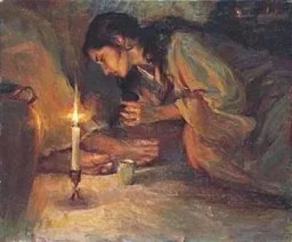

Mary Anointing
A sweet musk fragrance drifts through the room as Mary, the sister of Martha and Lazarus, pours pure nard on the feet of Jesus. The perfume soothes and calms, creating a homely, open-hearted atmosphere. While all the gospels have a version of Jesus being anointed by a woman (Mark 14:3–9; Matthew 26:6–13; Luke 7:36–50; ), as John’s gospel tells this story (John 12:1–8), the anointing marks the beginning of the great passing over of Jesus. In John’s gospel, this scene of pathos is set six days before the Passover, at the home of Martha and Mary, in the small village of Bethany that is on the eastern slope of the Mount of Olives just outside Jerusalem. For John, Mary’s tender pouring out of love as she anoints her beloved companion, prefigures and prepares Jesus for the sacred ritual when he will wash of his disciple’s feet, walk the way of the cross and be anointed as his crucified body is placed in the tomb. Hence, every year we listen to this alluring story on the Monday of Holy Week, inviting us to participate in and enact the same out-pouring of love as we follow the way to Calvary, entering into the emptiness of the tomb and are transformed in the contemplative awakening of resurrection.
Vividly, John portrays how: “Mary took about a pint of the fragrant oil (μύρου myrou) pure nard, (νάρδου πιστικῆς nardou pistikēs) an expensive perfume; she anointed (ἤλειψεν ēleipsen) the feet of Jesus and wiped them with her hair. And the house was filled with the fragrance of the perfume.” Notice how both Mary and Jesus are silent in this tender loving. Reciprocally, we as participants, are invited to share in the same intimate silence, to behold and simply be, to hold and become infused in the beauty of the scene, one with Mary, one with Jesus, one with ourselves, one with all those over the centuries who have prayed with this passage. And as we breathe in the sensuality of the organic oil of nard poured and massaged into Jesus, we imbibe the luxuriousness of the nard’s soothing. We deeply sense Mary’s healing touch. We feel the response of Jesus. The fresh aroma of the nard tends and ones our physical senses of smell and touch to our spiritual senses, creating a single sensorium that is both sensual and transcendent. The exchange within this tender, mutual love draws us deeper and beyond, into the perfume distilled in our hearts, into a touch that ones, in an indescribable, affectionate oneing. Still, the aroma stays with us, calming, softening, stilling, drawing us to depthless depths, until there is only love. Here, as Augustine appreciates, touch becomes the end of knowing. We pass beyond all conceptual knowing and pass-over into the oneing. Past, present and future one and we meet the promise of our future already present in this Kairos moment. This one, delicate, moment in time, becomes a turning point of luminous oneing, seeing and being. We are being invited to participate in this anointing, to be one with Mary and pour out the perfume of our hearts on the feet of Jesus, on the feet of our world. At the same time, we are drawn to be one with Jesus, and allow ourselves to be anointed and truly feel the touch that is at once painful and blissful, strengthening and renewing this amorizing energy of love pouring out. We are called to be like Mary and “touch with [our] own hands the Word of Life” (1 Jn 1: 1).
Ashes Anointing
As we settle into these forty days of Lenten time in the Christian calendar, we are in the third year of the covid pandemic, with a rising physical, mental, emotional and spiritual anguish haunting our collective unconscious and consciousness. We are faced too, with the trauma of an election year, and are in the midst of the ever-pressing climate crisis. There is so much we need to anoint. Lent begins on Ash Wednesday (March 2nd) with an anointing with the powerful symbol of ashes. While literally these ashes come from the burning of the palm branches from the Palm Sunday of the previous year, the power of this deep symbol of ashes anointing, goes far deeper. In being anointed with ashes, we offer all the desire of our heart longing to burn with love like incense. We offer ourselves. And in the ritual blessing, as we imbibe the pungent aroma of the ash, feel the touch of the grit, we are reminded of the fire of the universe’s origins, of our identity as earthlings with origins in star dust, of fire that is creative and of fire that destroys. We touch the agony and the ecstasy oned in the paschal dying and rising of Jesus. Our hearts know intimately that even what looks like ash is holy.
Swāmī Abhishiktānanda’s poem to the sacred mountain Arunāchala, (his symbol of the divine), vividly captures the intensity of the symbol of ash. Awakening our sensual transcendence, he stirs us to be the ash in this anointing:
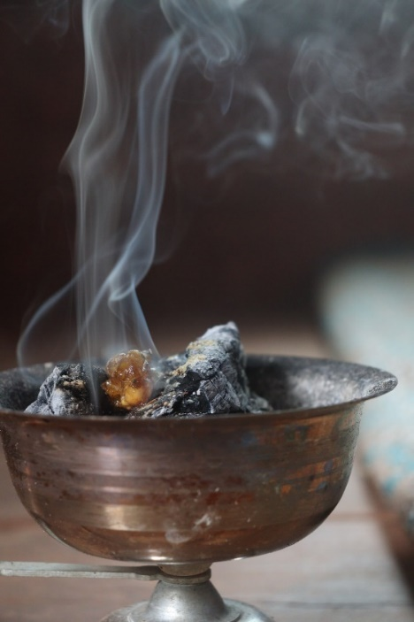
And I will burn myself like incense
I offer before You,
which has come from You and goes to You,
nothing but You Alone, “I will sing... my beloved”:

… And I have ashes too, pure white ashes to sign
Your forehead and Your breast,
Your shoulders and Your arms …

Ashes, my Arunāchala,
leftover from my heart where You’ve burned
like a devouring flame …

Like the fragrance of the nard, we can smell the incense, touch the grey-white ash, feel the oneing of time and eternity in this Lenten thin time. We can ritually sign with ashes of love, all that is wounded, fearful, unfree in our world, as all the loving of our heart becomes love poured out. Ultimately, we can offer ourselves to this devouring living flame of love burning in our heart, until our hearts are transparently aglow.
Jesus’ Anointing
On the eve of Passover, now commemorated as Holy, or Maudy Thursday, these ritual actions of anointing come to a climax with Jesus washing the feet of his companions. As with Mary’s anointing of Jesus, John’s gospel places us in the sensual pathos of this moment, when he portrays how: “Jesus, got up from the meal, laid aside (τίθησιν tithēsin) his outer clothing, and wrapped a towel around his waist. After that, he poured water (βάλλει ὕδωρ ballei hydōr) into a basin and began to wash (νίπτειν
niptein) the feet of his disciples, drying them with the towel that was wrapped around him” (John 13:4-5). Again, John focuses on the anointing of feet, and this time Jesus is the one who anoints by pouring out all the love of his heart in washing the feet of all those who are with him, in the same way that he will pour out all the blood and water from his body in the hours to come.
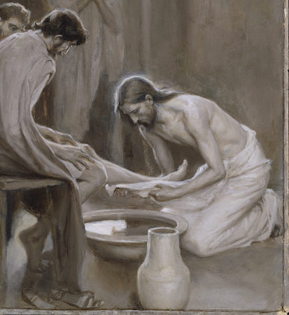
Our senses heighten, as John describes Jesus removing outer layers of clothing so that his heart may be exposed. The intensity of the loving continues to amplify as we listen to the trickle of the water pouring into the bowl, imbibe the perfume of the fresh aroma, feel the tenderness of feet being immersed in cleansing water, melt into the caressing touch of Jesus, until we are immersed in the sensualized transcendence of our oneing, in a mutually indwelling becoming. The desire of Jesus “that [we] be one (ἓν hen)” (Jn 17:21) is being realized. We are contributing to all of us becoming body of Christ. Artistically, Beatrice Bruteau invites us to truly embody the revolutionary nature of the transformation in identity, that takes place in this oneing and hear Jesus passionately acclaim:
I will no longer call you servants but friends. There is to be no distance between us. You are entirely in my confidence. Everything I have heard from my Father I have told you. I have not kept anything back, and have not claimed any privilege. We are friends, all equal. Everything I have done you can do as well. You can do more, and I hope you will. Sharing my life with you has been my love for you. No one can have greater love than this than to be willing to give your whole life to your friends. Do you see how it is? That a friend’s life lives inside you? And you live in your friend? It’s that kind of love. That’s the kind of love we have with the Father. The Father in in me and I am in the Father; I am in you and you are in me; the Father is in you and you are in the Father; you are in each other.
Do you see how it is? We are friends, all equal in this mutual indwelling in Jesus, in the Father, in the source of all life.
May we as the contemplative evolutionary network pour the nard of our heart through our contemplation and become nard to anoint our wounded world this Lent. May the ashes of our heart that form from the loving of this living flame until there is no more ash, only living flame. May we be vulnerable in having our feet washed and washing each other’s feet. And may we, like Jesus give the whole of ourselves to this loving.

De Trinitate, 1.19.18.
Beatrice Bruteau, The Holy Thursday Revolution (Maryknoll: New York, 2005), 59-60.

